Negative Feedback Experiment

By: David Clarke
Course: Electrical & Electronic Engineering2
Date:11/2/2000

Abstract

It can be shown that through a systematic approach, the characteristics of the standard LM741 op-amp can be evaluated. Two circuit configurations in particular are used, the op-amp circuit with and without negative feedback (NFB) applied. The input resistance, output resistance, gain and frequency response of the two configurations considered. In many cases the graphical responses obtained are the most useful criterion for giving conclusive evidence of the profits and loses in using voltage derived negative feedback. This conclusive evidence from theory and experiment is described in detail in the latter stages of this report.

Introduction

First of all, if there is a connection from an output to an input of a system, generally we have feedback. The term comes from the idea that something is fed back to the input from the output which has an effect on the overall performance of the system. The operation is often called ‘adding a feedback loop’. Look at [Figure 1] to see the black box representation of using two types of feedback with an op-amp.

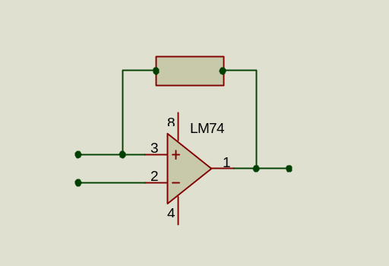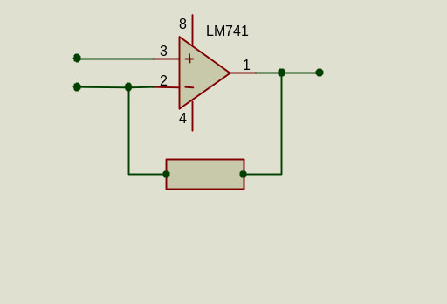
β
β

(a) Positive feedback (b) Negative feedback
[Figure 1]

Feedback can be used to pick off some output voltage or current and reintroduce it at the input of the circuit. It is the way it is fed into the input that causes changes in circuit performance to occur, i.e. it can reinforce (add to) the input signal or it can oppose (subtract from) the input signal. The report will concentrate on the latter i.e. negative feedback.
If the feedback subtracts from the input signal it is called negative feedback (NFB) and results in an output signal that is smaller than it would have been without the feedback connection. Circuits using negative feedback are usually stable, predictable, linear circuits with well-defined parameters and characteristics.

Principles of Methods

1). To measure the input resistance, make up a potentiometer using the input resistance of the input resistor of the amplifier and an external resistor and adjust the external resistor until half the applied voltage is dropped across it and half across the input resistance of the amplifier. Also make sure that the output from the amplifier is more or less sinusoidal and not limiting in any way. If this is true then the amplifier is obviously not linear and the test will be invalid.

2). To measure the output resistance. The method is very similar to measuring the input resistance, but now a switch is involved in the circuitry as well. Set the output voltage to some convenient number of square on the scope with the switch open. Close the switch and adjust the resistance until half the deflection is observed.

3). To measure the gain of the amplifier. Raise the input voltage slowly while looking at the output voltage until the output voltage becomes non-sinusoidal.

4). To measure the frequency response of the amplifier, set the output to, say, 10Vp-p at the lowest frequency 10Hz and kept at this level as the frequency is raised. When approaching the 3db point (the cut-off frequency) take smaller steps to increase the accuracy of the result.

Results

PART I – Amplifier with No Feedback Applied

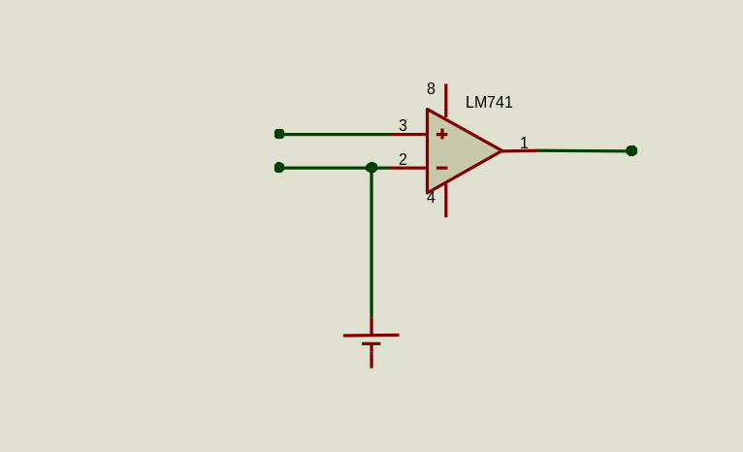
Vo
Vin
[Figure 2]

1). Measuring the input resistance:

Input voltage = 16.0 mV

We need half of the input voltage to appear across the variable resistor R_{var.} It is known that 8.0 mV is dropped across R_{var} when it has the following resistance value.

R_{var} = 1200Ω

Hence the input resistance of the op-amp equals the resistance value R_{var} at this particular voltage.

R_{in} = 1200Ω

2). Measuring the output resistance:

Output voltage = 1.94V

We need half of the output voltage to appear across the variable resistor R_{var} when the switch is closed. It is known that 8.0 mV is dropped across R_{var} when it is adjusted to the following resistance value.

R_{var} = 620Ω

Hence the output resistance of the op-amp equals the resistance value R_{var} at this particular voltage.

R_{out} = 620Ω

3). Because the amplifier is very non-linear the gain cannot be defined as ouput/input. Instead the input/output characteristics of the amplifier (Vop-p against Vin-p) are plotted and the tangent to the curve at the origin is found. The slope of the tangent is the required gain.

The results are tabulated in [Table1]:

Vin(V) | Vout(V) |  | Vin(V) | Vout(V)
0.02 | 2.16 |  | 0.28 | 18.6
0.03 | 3.28 |  | 0.29 | 18.6
0.045 | 4.88 |  | 0.3 | 19
0.06 | 6.4 |  | 0.31 | 19.4
0.08 | 8.08 |  | 0.32 | 19.8
0.1 | 9.96 |  | 0.33 | 20.2
0.12 | 11 |  | 0.34 | 20.6
0.14 | 12.2 |  | 0.35 | 21
0.16 | 13.4 |  | 0.36 | 21.2
0.18 | 14.2 |  | 0.37 | 21.4
0.2 | 15.4 |  | 0.38 | 21.6
0.22 | 16.2 |  | 0.39 | 21.8
0.23 | 16.6 |  | 0.4 | 22
0.24 | 17 |  | 0.41 | 22.2
0.25 | 17.4 |  | 0.42 | 22.4
0.26 | 17.8 |  | 0.5 | 24.6
0.27 | 18.2
[Table1]

Graphical output achieved from the tabulated results is shown below in [Graph1]:

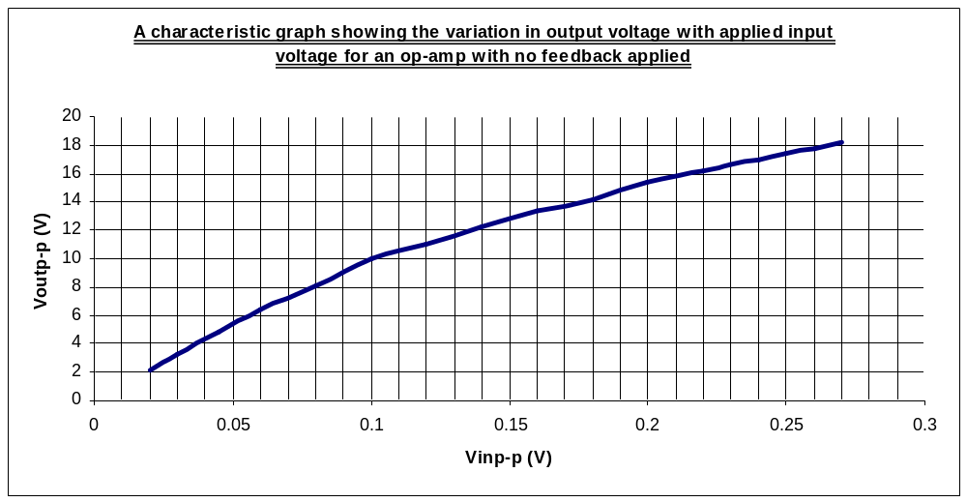[Graph1]
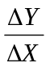

The slope of the tangent is change in Y(Voutp-p) with respect to the change in X(Vinp-p). By calculation the required gain is:-

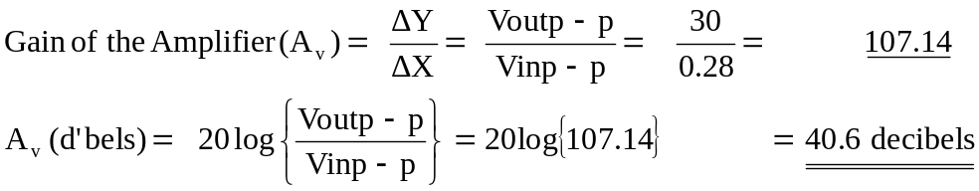

4). Measuring the frequency response of the amplifier.

The results are tabulated in [Table2], note the output voltage is kept constant at 10.00V:

Input(mV) | Frequency(Hz) | Gain (dB's) |  | Input(mV) | Frequency(Hz) | Gain (dB's)
104 | 10 | 39.66 |  | 220 | 11000 | 33.2
108 | 100 | 39.33 |  | 240 | 12000 | 32.4
116 | 1000 | 38.71 |  | 244 | 13000 | 32.25
128 | 2000 | 37.86 |  | 256 | 14000 | 31.84
140 | 3000 | 37.07 |  | 272 | 15000 | 31.31
144 | 4000 | 36.83 |  | 284 | 16000 | 30.93
152 | 5000 | 36.36 |  | 292 | 17000 | 30.46
166 | 6000 | 35.6 |  | 300 | 18000 | 30.46
180 | 7000 | 34.9 |  | 304 | 19000 | 30.34
190 | 8000 | 34.4 |  | 312 | 20000 | 30.1
194 | 9000 | 34.2 |  | 320 | 21000 | 29.9
212 | 10000 | 33.5
[Table2]

The graphical output achieved from the tabulated results is shown below in [Graph2] :

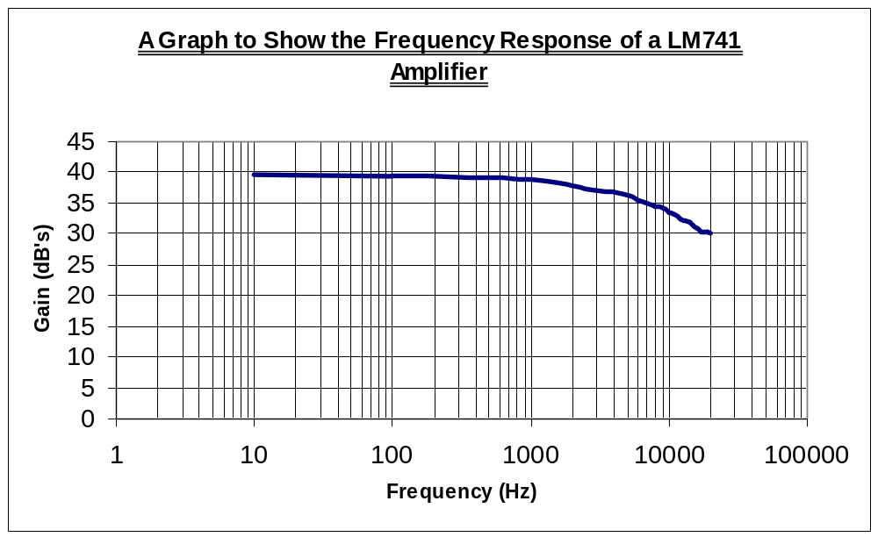[Graph2]
G_{uc}
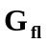
F_{u}

The cut off frequency (in this case the upper) is defined as the point on the frequency response graph 3dB’s down from the flat response level.

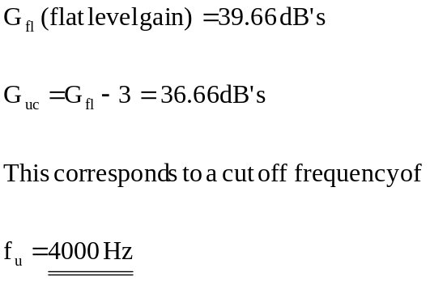

PART II – Amplifier with Voltage Derived, Series Applied NFB

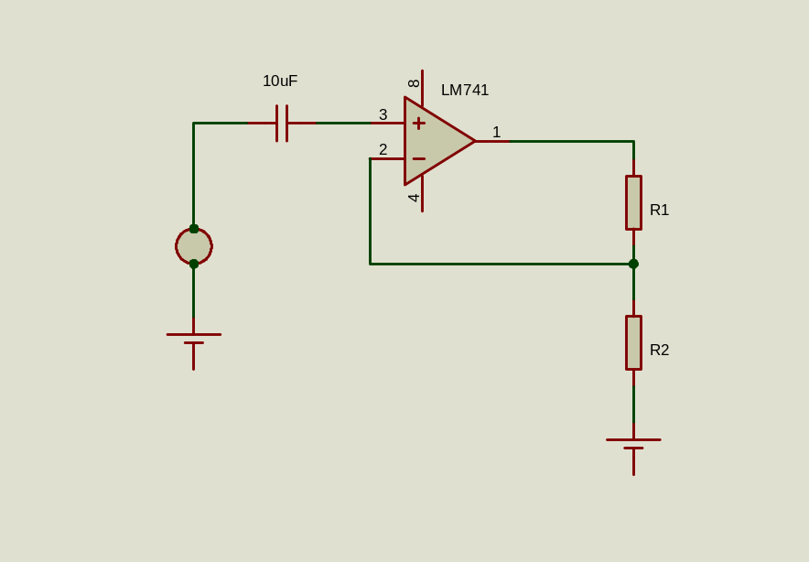
Vin
Vo
[Figure 3]

The load on the output caused by the network should be in the region of 10kΩ and the feedback factor, β, should be 0.1. Calculate the values of R1 and R2 to satisfy these conditions.

Input voltage (Vin) = 120 mV
Output Voltage (Vo) = 1V
Voltage measured at inverter = 120mV

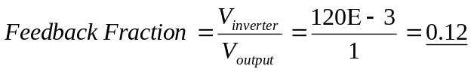

If steps 1, 3 & 4 are now repeated:-

1). Measuring the input resistance:

Using the same method encountered in Part I -1).

Input Resistance = 12kΩ

Using feedback theory, taking the input resistance and gain from part I plus the additional feedback fraction from the start of part II. The theoretical value for the input resistance of the op-amp circuit with NFB can be calculated:

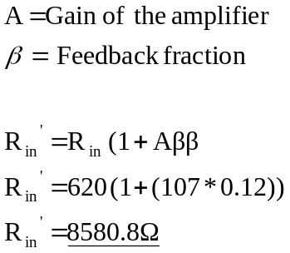

3). The slope of the tangent is the required gain.

The results are tabulated in [Table3]:

Input Voltage (V) |  | Output Voltage (V)
0.12 |  | 1
0.24 |  | 2
0.42 |  | 3
0.54 |  | 4
0.64 |  | 5
1.36 |  | 10
1.92 |  | 15
2.8 |  | 20
3.52 |  | 24
[Table3]

Graphical output achieved from the tabulated results is shown below in [Graph3]:
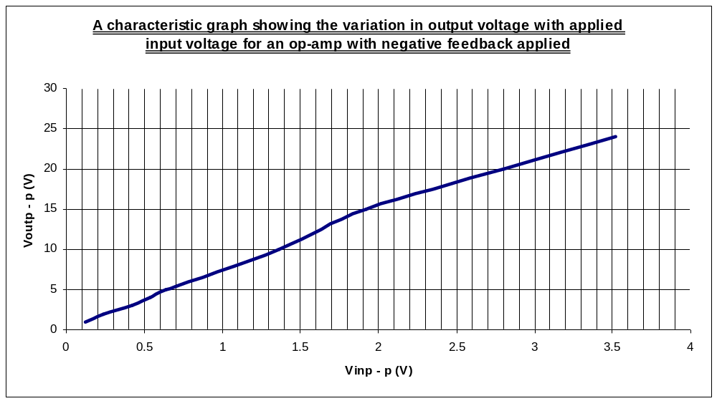[Graph3]

The slope of the tangent is change in Y(Voutp-p) with respect to the change in X(Vinp-p). By calculation the required gain is:-

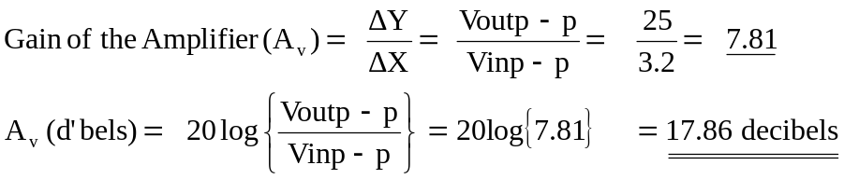

4). Measuring the frequency response of the amplifier.

The results are tabulated in [Table4], note the output voltage is kept constant at 10.00V:

Frequency (Hz) |  | Gain (dB's) | Frequency (Hz) |  | Gain (dB's)
10 |  | 18.13 | 20000 |  | 16.59
100 |  | 18.13 | 25000 |  | 16.36
1000 |  | 18.13 | 30000 |  | 16.14
2000 |  | 18.13 | 40000 |  | 16.14
3000 |  | 17.85 | 44000 |  | 15.7
4000 |  | 17.85 | 48000 |  | 15.7
5000 |  | 17.72 | 50000 |  | 14.7
6000 |  | 17.72 | 56000 |  | 14.7
10000 |  | 17.33 | 60000 |  | 14.5
15000 |  | 16.95
[Table4]

The graphical output achieved from the tabulated results is shown below in [Graph4] :

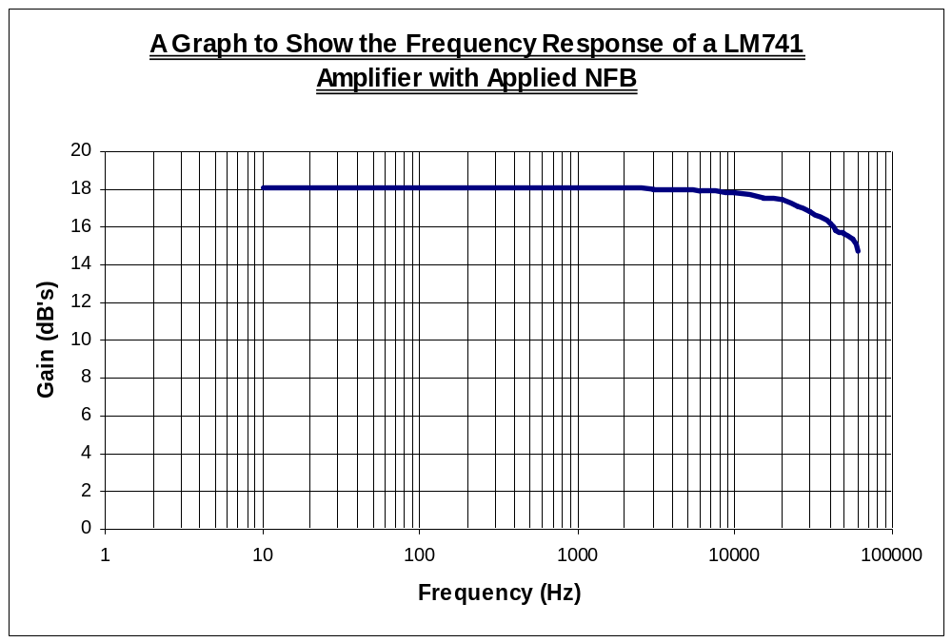 [Graph4]
G_{uc}
F_{u}

The cut off frequency (in this case the upper) is defined as the point on the frequency response graph 3dB’s down from the flat response level.

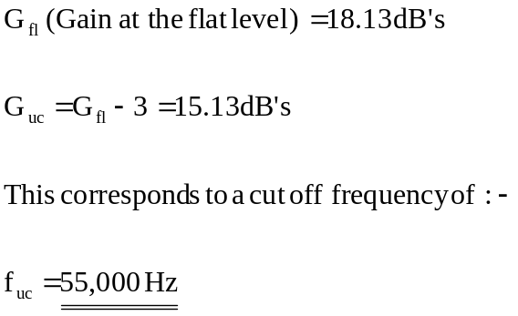

Discussion of Results / Conclusions

Graphical Results:-

Amplifier With No Feedback Applied:

Calculation of the gain of the op-amp from the gradient of the Vout versus Vin graph:

Gain = 107.14 (40.6 dB’s)

Flat level gain of the amplifier taken from the frequency response graph:

Gain = 39.66 dB’s

The upper cut off frequency of the op-amp at three decibels below this level:

F_{co} = 4000 Hz

Amplifier With Negative Feedback Applied:

Calculation of the gain of the op-amp from the gradient of the Vout versus Vin graph:

Gain = 7.81 (17.86 dB’s)

Flat level gain of the amplifier taken from the frequency response graph:

Gain = 18.13 dB’s

The uppercut off frequency of the op-amp at three decibels below this level:

F_{co} = 55,000 Hz

Comparison of Graphical Results:-

1). How the frequency response of the op-amp with negative feedback applied differs from that an op-amp with no feedback applied:-

- The overall gain of the amplifier decreases from 40.6 to 17.86 decibels. A decrease by a factor of 2.27
- The bandwidth of the band pass region increases from 4000 to 55000 Hz. An increase by a factor of 13.75.

Hence a decrease in the amplification of the signal results in a large increase in the uppercut off frequency and thus the bandwidth of the band pass region.

So there is a distinct relationship between the uppercut off frequency and the gain of the op-amp. It can be seen that if the gain is multiplied by the value of the uppercut off frequency for both cases, an interesting result occurs:
Result for the amplifier with no feedback applied:

Comparing this result with the result for the amplifier with negative feedback applied:

Both results are approximately equal, they only differ in value due to errors in the values used for calculation. If the gain and uppercut off frequency was produced to a very high accuracy it could be said that both results would be the same. Hence the product of these two terms are equal to a constant.

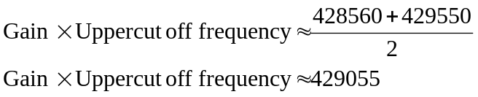

Which can be written as:

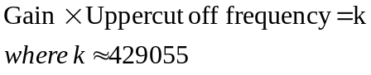

2). How the output voltage with applied input voltage of the op-amp with negative feedback applied differs from that of an op-amp with no feedback applied:-

- The response is more linear. This greater grade of linearity in the response is reflected in the greater stability of this amplifier arrangement.

Comparison of Other Graphical and Measured Results with Theory:-

Amplifier With Negative Applied Feedback:

Gain calculated from theory:-

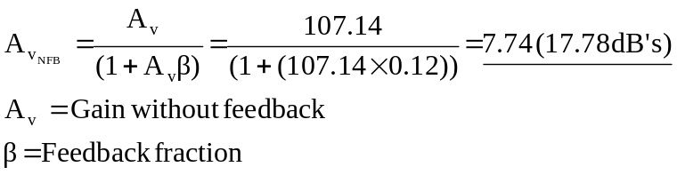

Calculation of the gain of the op-amp from the gradient of the Voutp - p versus Vinp - p graph:

Gain = 7.81 (17.86 dB’s)

Comparing the two results there is very little difference between this theoretically calculated value and the graphically interpreted result. This shows that the theoretical calculation does hold true and thankfully because of the linear nature (this is true for the most part for the gain graph produced using NFB, and for the least part without) of the output voltage with applied input voltage for both systems the gradient of the slope is accurate.

Input resistance calculated from theory:

Using feedback theory, taking the input resistance and gain from PARTI plus the additional feedback fraction from the start of PARTII. The theoretical value for the input resistance of the op-amp circuit with NFB can be calculated:

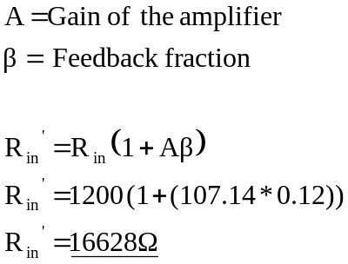

Actual experimental calculation of Input resistance:

Input Resistance = 12kΩ

There is a large (approximately 25%) difference in the experimental and theoretical value of the input resistance. The experimental value of the input resistance was measured using Method 1) In the Principles of Methods section. The was no large inaccuracy in the measurement of the resistance, everything was estimated visually from the oscilloscope output. All that can be said is that the theoretical equation for input resistance does not hold fully true for this particular aspect of the op-amp (due to a large spread in the available gain values, calculated by choosing a particular slope to the input output voltage graph characteristic).

